Answers

Convert the following binary values into denary: [2]
  - 00011011 27
  - 11100110 230

Circle the binary value below that represents the denary value 87. [1]
  - 01011010
  - 11000100
  - 01010111
  - 00011010

Convert the following values to and from Hexadecimal: (Show your working). [8]
  - Denary 37 to Hex 25
  - Denary 59 to Hex 3B
  - Hex 11 to Denary 17
  - Hex 2F to Denary 47
  - Hex 1A to Binary 0001 1010
  - Hex 16 to Binary 0001 0110
  - Binary 0011 0111 to Hex 37
  - Binary 1101 1111 to Hex DF
- Multiply the binary value 0011 0010 by 2, by using a logical shift. [1]
0110 0100
- Colours in art packages are often given using hexadecimal as illustrated below with #00ccff.
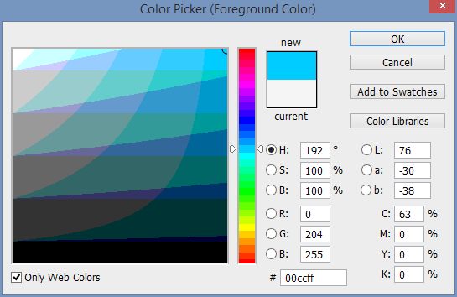
Explain why hexadecimal is used rather than the actual 24-bit colour value. [2]
Hexadecimal is easier for humans to understand/remember/enter/write than binary (1) as it is a shorter representation of the binary (1).
The code only takes up six digits on the screen rather than 24 (1) so it is more easily displayed on the GUI (1).
It is quicker/shorter/less prone to error (1) to enter a six-character hexadecimal value to reproduce an exact colour than it is to enter a long binary value (1).

- Add 00100111 to 00101010. You should include your working. [2]
 |  | 1 |  | 1 | 1 | 1
 | 0 | 0 | 1 | 0 | 0 | 1 | 1 | 1
+ | 0 | 0 | 1 | 0 | 1 | 0 | 1 | 0
 | 0 | 1 | 0 | 1 | 0 | 0 | 0 | 1
- Add 00100111 to 00111010. You should include your working. [2]
 |  | 1 | 1 | 1 | 1 | 1
 | 0 | 0 | 1 | 0 | 0 | 1 | 1 | 1
+ | 0 | 0 | 1 | 1 | 1 | 0 | 1 | 0
 | 0 | 1 | 1 | 0 | 0 | 0 | 0 | 1
- An error occurs when you try to add 11011001 to 11100100 and store it as an 8-bit number.
Explain the error that occurs. [2]
Overflow error (1).
An overflow error occurs when the addition requires a carry bit into the ninth bit (1).
[Total 20 marks]

